**Academic Year: 2023-24 Semester: V**

**Class / Branch: TEIT Subject: DevOps Lab**

**Name of Instructor: Prof. Sonal Jain/Prof. Neha Deshmukh**

# Experiment No. 4

**Aim: To install and configure Jenkins to test and deploy an application with Maven.**

**Theory:**

Jenkins is an open-source automation tool written in Java with plugins built for Continuous Integration purpose. Jenkins is used to build and test your software projects continuously making it easier for developers to integrate changes to the project, and making it easier for users to obtain a fresh build. It also allows you to continuously deliver your software by integrating with a large number of testing and deployment technologies.

“Continuous Integration is a software development practice where members of a team integrate their work frequently, usually each person integrates at least daily - leading to multiple integrations per day. Each integration is verified by an automated build (including test) to detect integration errors as quickly as possible.” In simple way, Continuous integration (CI) is the practice of frequently building and testing each change done to your code automatically.

Jenkins is a self-contained, open-source automation server which can be used to automate all sorts of tasks related to building, testing, and delivering or deploying software.

To install Jenkins following software packages are required

1. GIT (git-scm.com)
2. Notepad++ ( https://notepad-plus-plus.org/downloads/)
3. Latest Java development kit (JDK)
4. Jenkins
5. Apache Maven (Optional)

Installation Steps for Jenkins on Ubuntu 18.04

Step 1-: Update ubuntu repository

Step 2-: Install Java development kit

Step 3-: Download the latest Jenkins .deb file from jenkins.io website by selecting ubuntu distribution.

Step 4-: Once downloaded double click on file

Step 5-: Once installation is done, you can test the application on http://localhost:8080 in browser

Step 6-: First time when you open Jenkins portal it will ask to put admin default password which is stored in /var/lib/jenkin/ Admin password file

Step 7-: So open through terminal and copy password and add to portal link to install plugin

Step 8-: Once installation is done open Jenkins dashboard.

**Task to be performed as a part of this experiment:**

**Task 1:** To display your name on Jenkins dashboard by creating a message in system settings

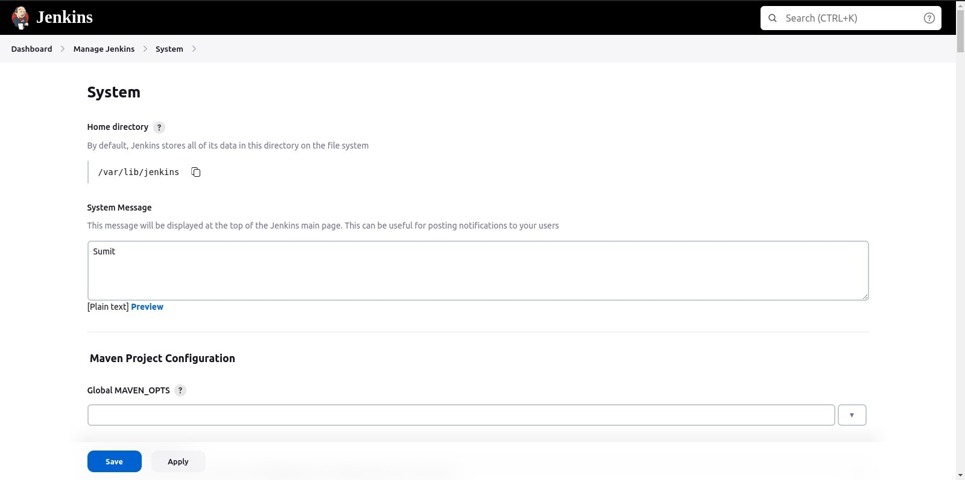

**Task 2:** To create a new item(it means project) of any name

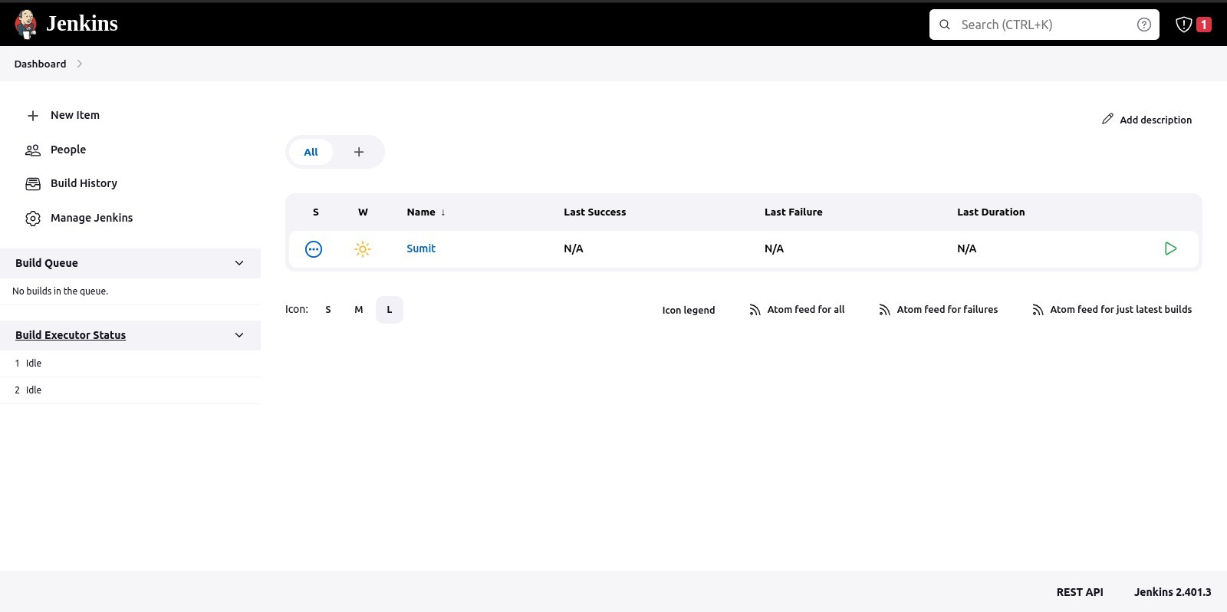

**Task 3:** Assign build trigger as periodic to build the project after every minute.

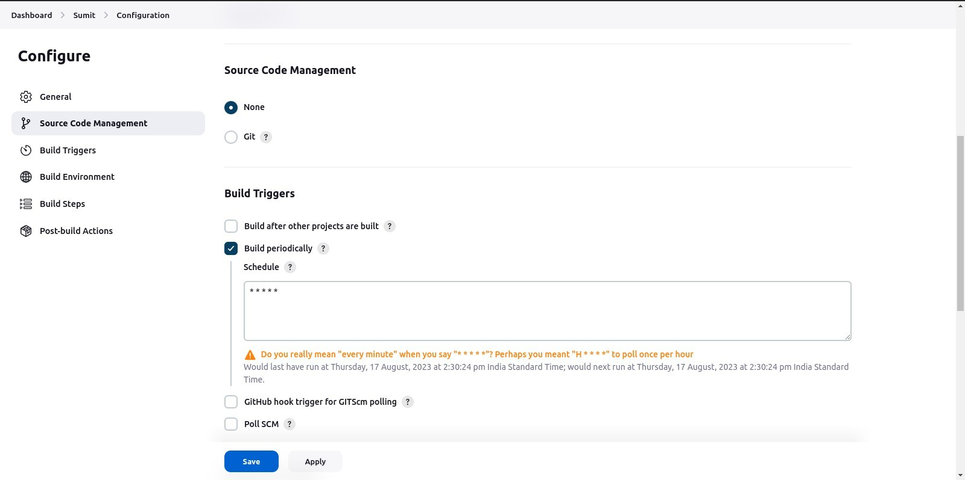

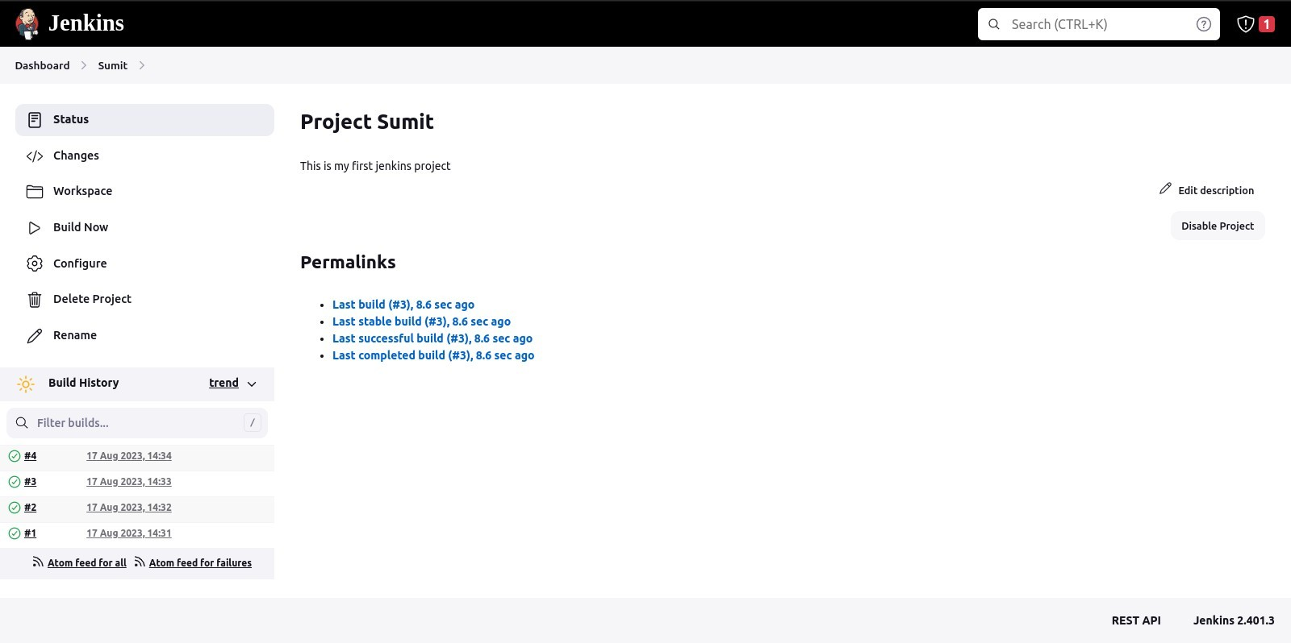

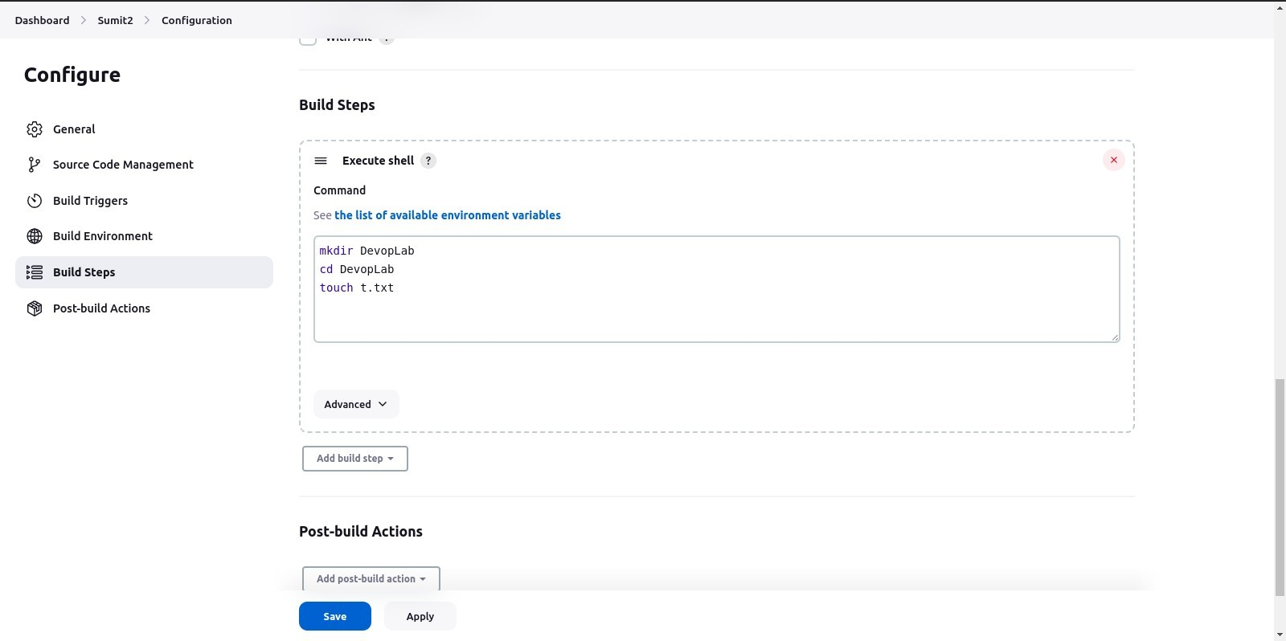**Task 4: To execute certain task by writing commands under “execute shell” (Drop down option of Build step)**

**Build the project manually and check the console output.**

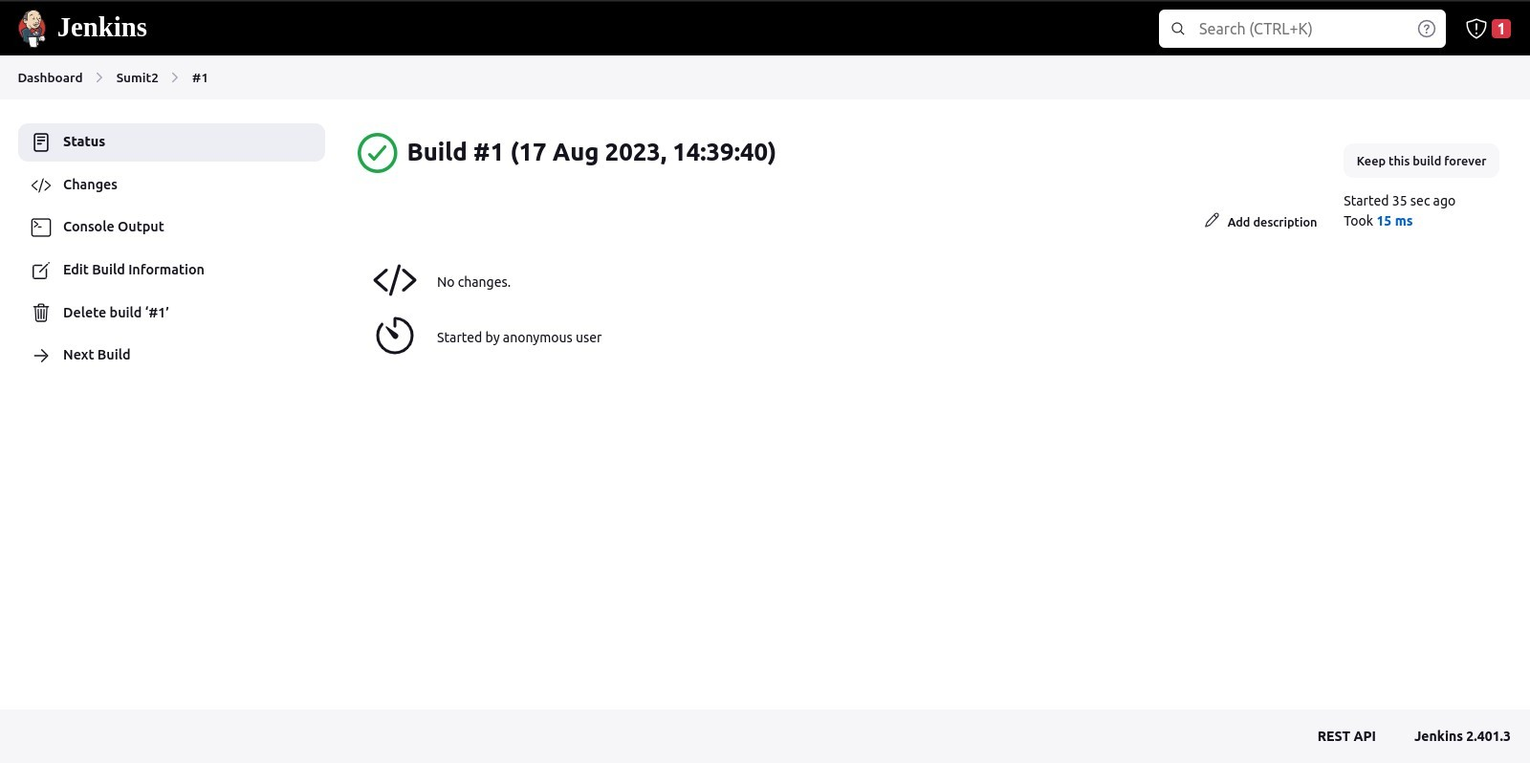

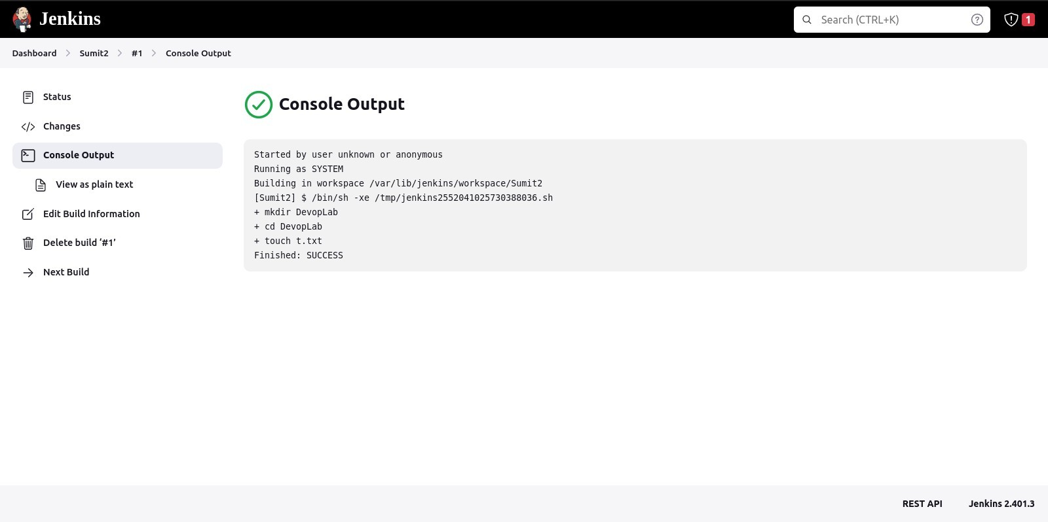

**Task 6**: Directory saved at *var*/lib/jenkins/workspace/projectname where you can find folders and files that were created

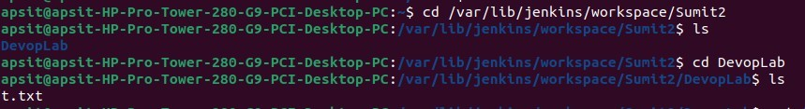

**Task 7**: Built an item(project) using git repository by putting github link given on moodle under git repository.

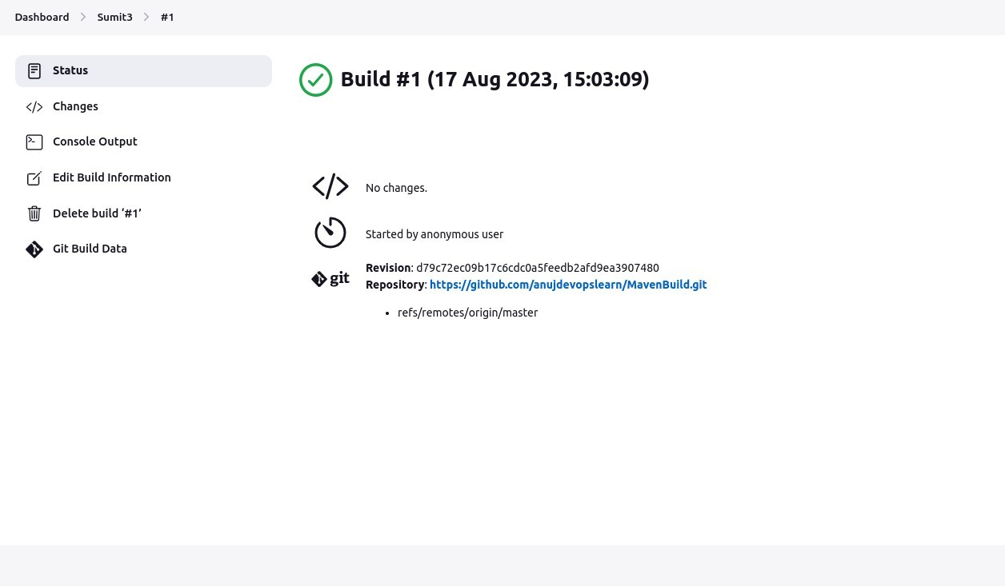

Output for the maven file built using git repository

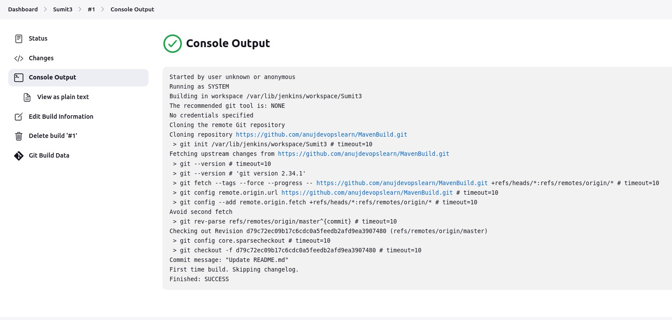

Conclusion: In this experiment students have understood various steps involved in installation of Jenkins and Maven. Also, they have learned how to create, build and deploy a freestyle and maven job on Jenkins.